**Essential Google Cloud Infrastructure: Foundation**

**Virtual Networks**

Virtual Private Cloud (VPC)

* Projects
* Networks
* Subnetworks
* Regions
* Zones
* IP address (internal and external)
* Virtual Machines
* Routes
* Firewall Rules

Project

* Associates objects and services with billing
* Contains up to 5 networks that can be shared/peered

Network

* No IP address range
* Global, spans all regions
* Contains subnetworks
* Available as default, auto or custom

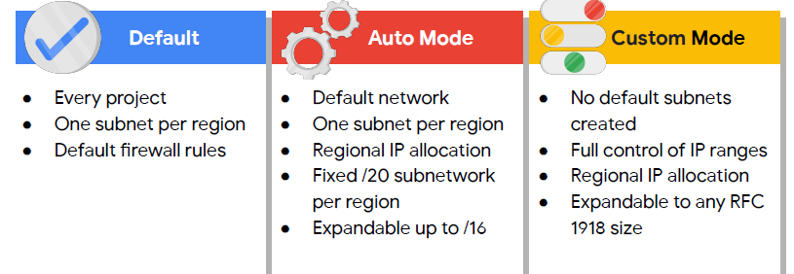

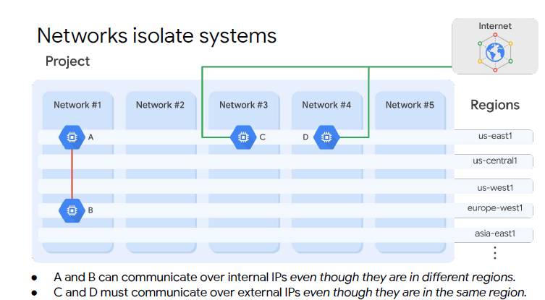

A single VPN can connect on-prem to your GCP network

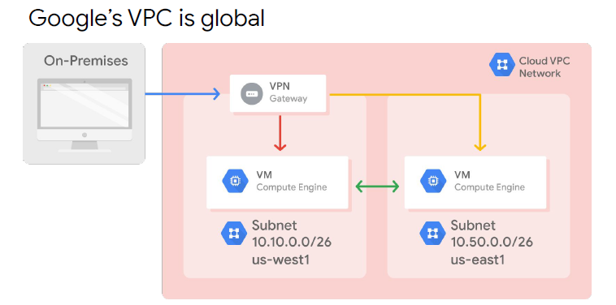

Because a region contains different zones, subnets can cross zones

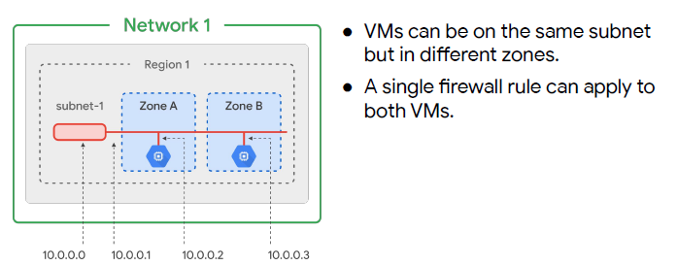

VMs have internal IP address and optional external IP address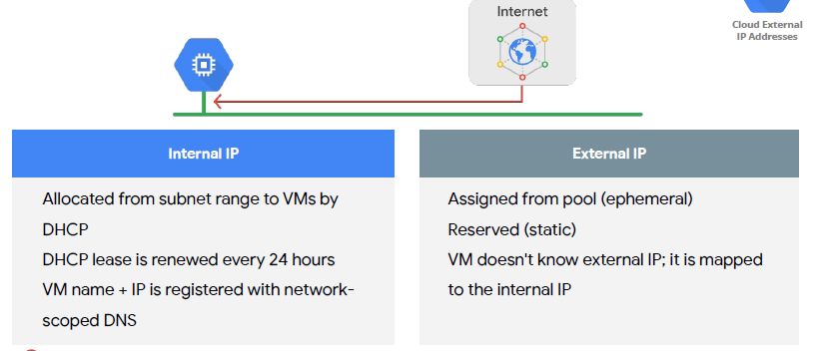

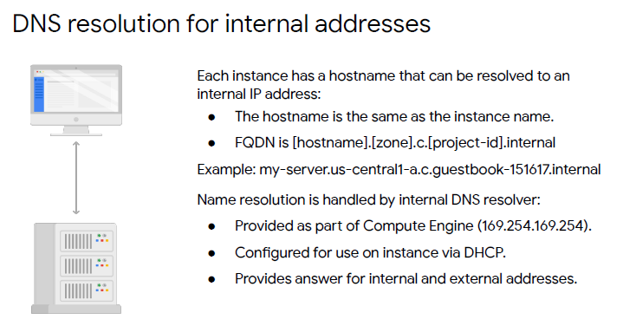

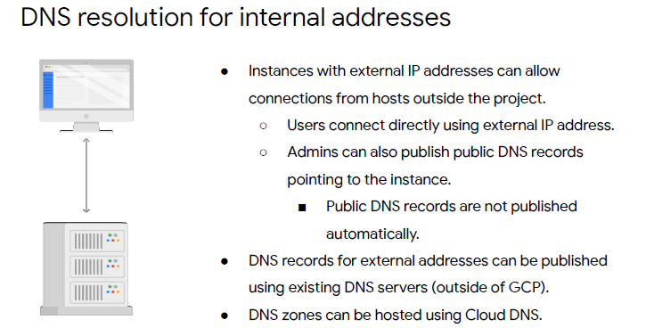

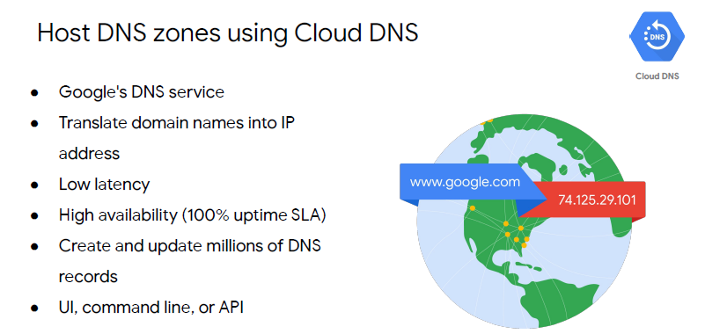

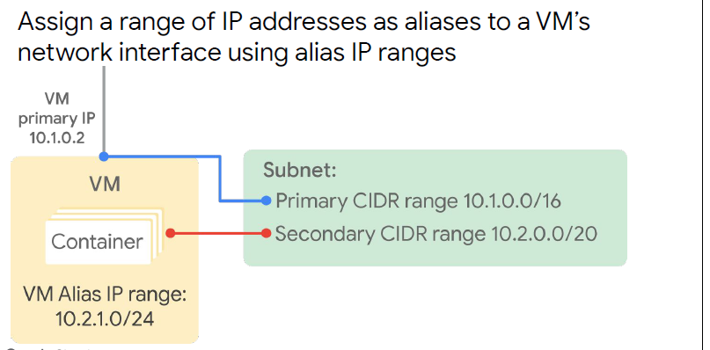

Every network has:

Routes that let instances in a network send traffic directly to each other

A default route that directs packets to destinations that are outside the network

Firewall rules must allow the packet

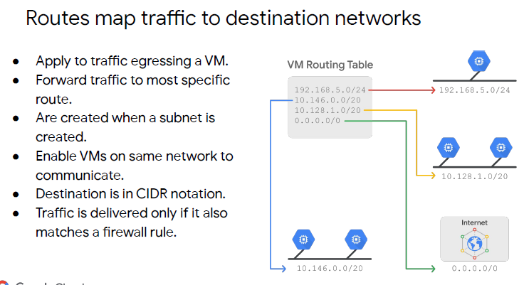

Firewall rules protect your VM instances from unapproved connections:

* VPC network functions as distributed firewall
* Firewall rules are applied to the network as a whole
* Connections are allowed or denied at the instance level
* Firewall rules are stateful (all traffic in either direction allowed)
* Implied deny all ingress and allow all egress

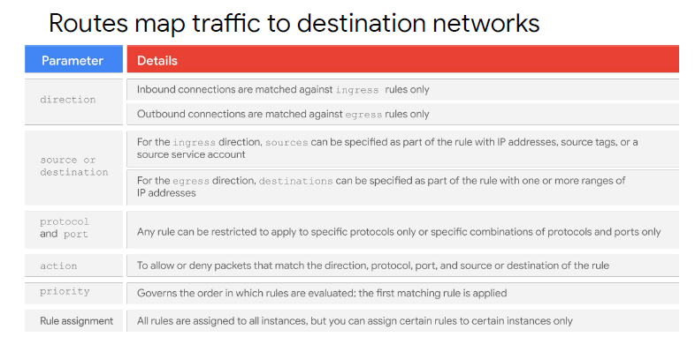

Egress firewall

* Egress firewall rules control outgoing connections originating from GCP network
* Use destination ranges to protect from undesired connections initiated by VM instance to external hosts or other internal VMs

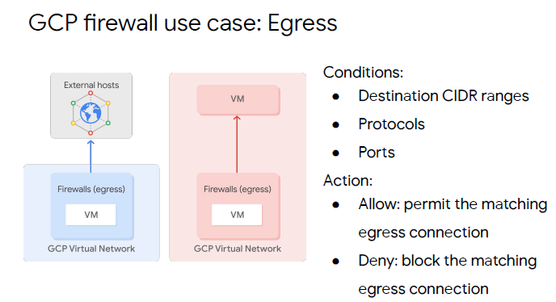

Ingress firewall:

* Ingress firewall rules protect against incoming connections to the instance from any source
* Source slide rangers used to prevent undesirable incoming connections from either external host or internal VMs

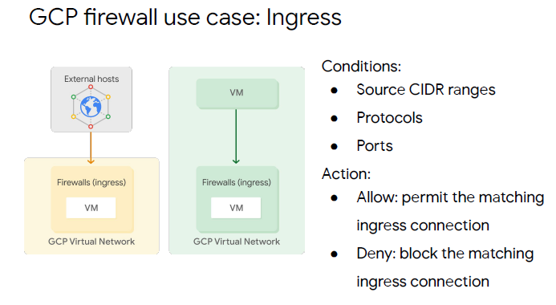

Network Pricing Table

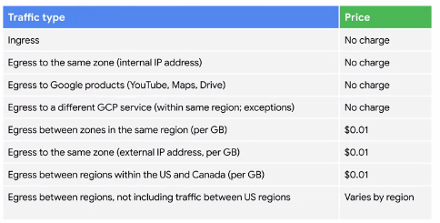

External IP pricing

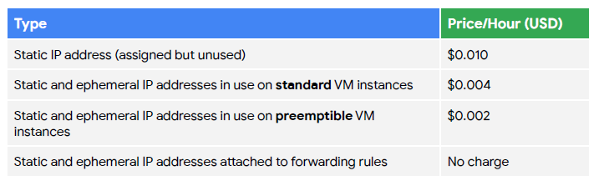

More expensive to have an unassigned static IP address than an assigned static IP address

Below are some common network designs:

* Increase network availability, place 2 VMs in multiple zones but within the same subset. Create firewall rules against subnet   
  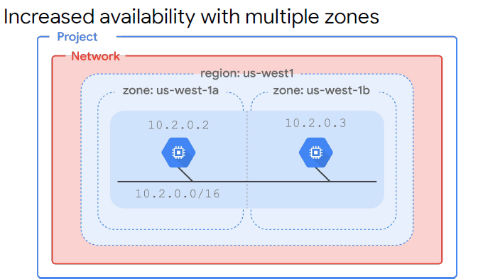
* Globalisation with multiple regions: provides an even higher degree of failure independence. Robust systems across different failure domains. Use load balance to route traffic to the region that is closest to the user. Better latency 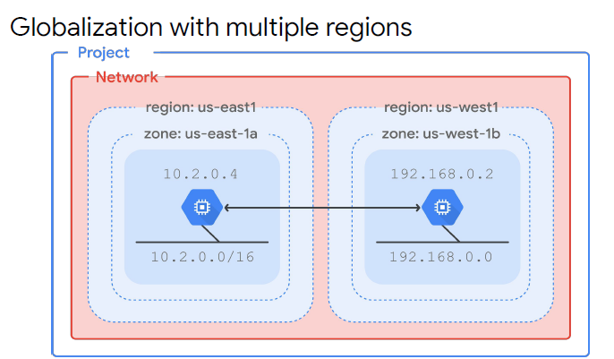

Cloud NAT

* Cloud NAT (Network Address Translation service) enables VMs without an external IP address to access the internet in a controlled manner (i.e. updates, patching, config management)

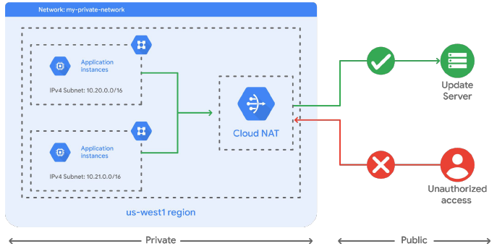

Private Google Access

* Enable Private Google Access to enable instances without external IP address to reach external IP addresses of Google APIs and services (e.g. if internal instance needs to access cloud storage bucket)
* Enabled on a subnet-by-subnet basis
* Has no affect on a VM that has an internal IP address
* In the below image, VM B1 is the only instance unable to access Google APIs and Services

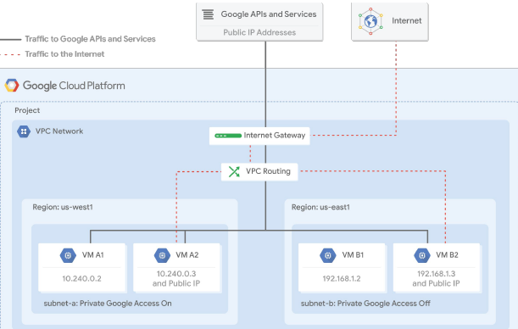

**Virtual Machine**